ENGLESKI JEZIK
-primjeri dobre prakse u nastavi stranog jezika uz udžbenik Hello World 6 i Hello World 7
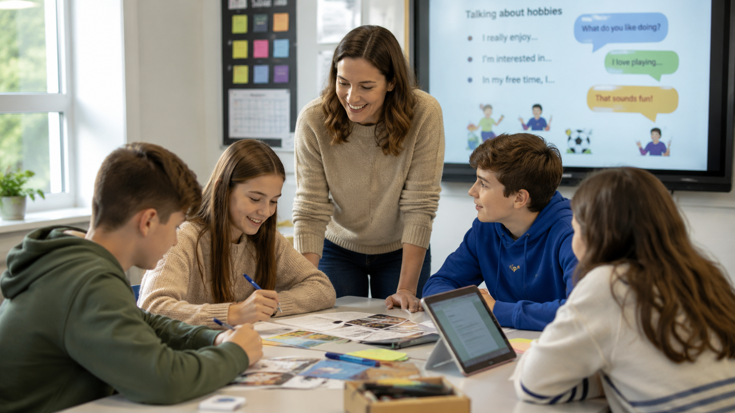
Primjeri dobre prakse iz nastave engleskog jezika nastali su kroz aktivnosti povezane s kurikulom za šesti i sedmi razred osnovne škole u školskoj godini 2025./26. Prikazuju kako se kroz kreativne i suvremene metode rada mogu razvijati jezične vještine, komunikacijska kompetencija, digitalna pismenost, suradnja i samostalno izražavanje na engleskom jeziku.
Aktivnosti su osmišljene tako da povezuju propisane nastavne sadržaje s temama bliskima svakodnevnom životu, interesima učenika i suvremenom načinu učenja. Kroz mentorsko vođenje, uporabu digitalnih alata i poticanje aktivnog sudjelovanja, nastavni sadržaji postaju zanimljiviji, primjenjiviji i usmjereni na razvoj ključnih kompetencija.
Danijela Šajtar

- The Solar System
https://create.kahoot.it/details/958cbbb4-0b4f-43b2-80a3-f629623c8f74

- The Solar System 2
https://create.kahoot.it/share/the-solar-system-2/251659c9-db48-4552-9ce8-673af2899cb7

- The Living Planet
https://wayground.com/admin/quiz/6a269d65a777621141ae4fc0

- The Portal
https://wordwall.net/resource/114662613

- Mental Health 1
https://create.kahoot.it/share/mental-health/dd30e685-b5c3-405c-92d2-0efaf040159d

- Mens Sana
https://create.kahoot.it/share/mens-sana/1aded9f6-30a2-4cf9-bc13-c2f50db2ce69

- Viral Content and Digital Responsibility

https://wayground.com/admin/quiz/6a26ac9da35db5f405ee7648

- Mental Health 2
https://create.kahoot.it/share/mental-health/c490c605-ab41-4c14-926d-214e3683caf0

- Bollywood
https://wayground.com/admin/assessment/6a26b97669005cfe6e0021d6?source=lesson_share

- Mind and Body
https://wayground.com/admin/assessment/6a26be9469005cfe6e002448?source=lesson_share

- India
https://wayground.com/admin/assessment/6a26c20747dad91b570544b1?source=lesson_share

- Indian Men's Sana 1
https://wayground.com/admin/assessment/6a26cbb8753f8d3a8b864941?source=lesson_share

- Indian Men's Sana 2
https://wayground.com/admin/assessment/6a26cc95e7a602f93c3483d2?source=lesson_share

YouTube video sadržaj:

- The Portal
https://youtu.be/M8sL_nOvM9s
- The Living Planet
https://youtu.be/ckFQKFwVHhE
- Viruses
https://youtu.be/X4GiNg42Y6U

- Čazma Tena i Patrik
https://youtu.be/sKJfoz851Uc
- Games
https://youtu.be/zKu9z1OgHwg

- AI u osnovnoj školi
https://youtu.be/6v4cgyG7SNE

- AI u osnovnoj školi 7.a
https://youtu.be/6v4cgyG7SNE

- Happy Children's Day
https://youtu.be/qIwjs9AY9kY

- The Ball, The Game
https://youtube.com/shorts/XFO2R3w2n2M?feature=share

- Demystifaying Mental Health
https://youtu.be/kIrVa6fLXx4

- Mens Sana n Corpore Sano
https://youtu.be/uljTsNWV0u0

- It's Gone Viral
https://youtu.be/lk2qohnzrY8

- Mental Health 2
https://youtu.be/Q9H9RNCE6yk

- Bollywood
https://youtu.be/RTZ7IdkH_fU

- Healthy Body
https://youtu.be/t53zm0a7u8w

- Mind and Body
https://youtu.be/jBDUdFpbd-8

- India
https://youtu.be/je-p_9hR_9E

- Indian Men's Sana
https://youtu.be/hACMldp2rfs

